New Pathway for the management of children following total thyroidectomy
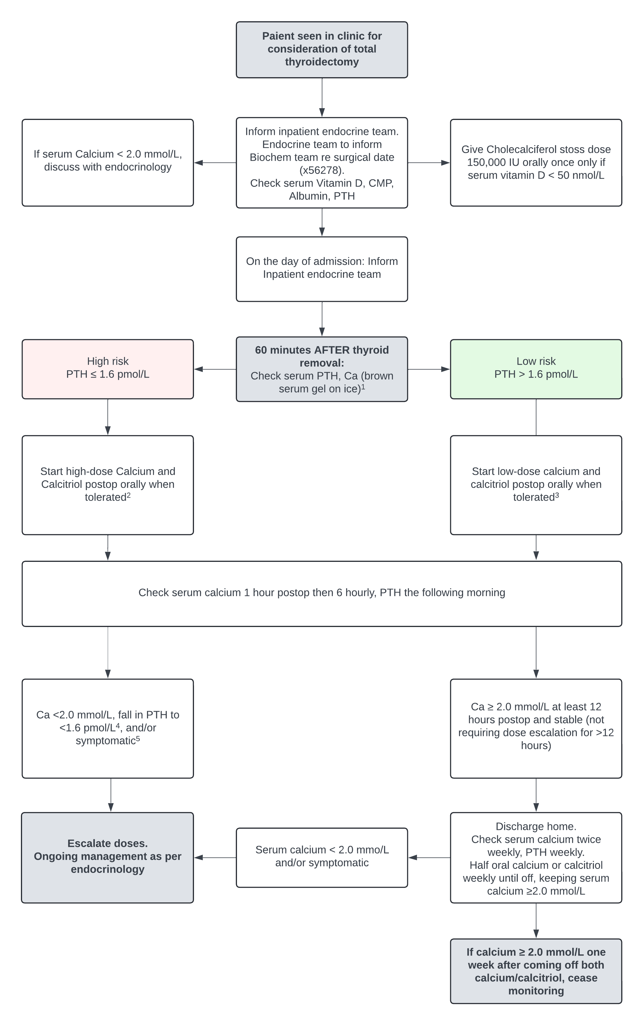
General notes:
- Usual Calcium dose is elemental calcium 50-150 mg/kg/day in 2 divided doses.
- Usual Calcitriol dose is 0.02-0.05 mcg/kg/day.

- Primary contacts for notification of initial PTH result
Monday to Friday 9 am to 5 pm: Endocrine SRMO x52601 or Endocrine Fellow via switchboard
Weekdays 5 pm to 9 am, Weekends, or public holidays:
- Patient under General Surgery bedcard: General Surgical resident x52723
- Patient under ENT bedcard: Specialty Surgery resident x52180

- High dose calcium/calcitriol dosing
Calcium:
If weight < 30 kg, give elemental calcium 600 mg BID
If weight > 30 kg, give elemental calcium 1200 mg TDS
Calcitriol:
If <3 years – 0.04 to 0.08 mg/kg/day in 2 divided doses
If weight < 30 kg, give 0.25 micrograms per dose twice daily
If weight > 30 kg, give 0.5 micrograms per dose twice daily

If patient is hypocalcaemic and unable to tolerate oral treatment, IV calcium correction should be considered.

- Low dose calcium/calcitriol dosing
Calcium:
If weight < 30 kg, give elemental calcium 300 mg once daily
If weight > 30 kg, give elemental calcium 600 mg once daily
Calcitriol:
If weight < 30 kg, give 0.125 micrograms/dose once daily
If weight > 30 kg, give 0.25 micrograms/dose once daily

If patient is hypocalcaemic and unable to tolerate oral treatment, IV calcium correction should be considered.

- Fall in serum PTH
A low PTH level should be interpreted with the serum calcium level. A low PTH level with a rapidly dropping serum calcium or low serum calcium level may indicate pending hypoparathyroidism. However, a low serum PTH level and a high normal/high calcium level may indicate appropriate PTH suppression due to hypercalcaemia and may necessitate reduction in the calcium/calcitriol dose.

- Symptoms of hypocalcaemia
Muscle spasms or cramps, numbness or tingling periorally or in the extremities, fatigue, tetany, seizures, laryngospasm, arrhythmia (prolonged QRS or QT).
- If patient is mildly symptomatic e.g. perioral tingling, numbness only, order an ionised calcium level and give a STAT order of:
<30 kg: Calcium 600 mg, Calcitriol 0.25 micrograms
>30 kg: Calcium 1200 mg, Calcitriol 0.5 micrograms
- If patient has severe symptoms of hypocalcaemia e.g. muscle spasms, tetany, seizures, arrhythmia, laryngospasm – consider STAT IV calcium correction.

